Land-Use Requirements of Modern Wind Power Plants in the United States

Paul Denholm, Maureen Hand, Maddalena Jackson, and Sean Ong

## Main points:

Metrics for land use literature:

the area impacted,

the duration of the impact, NOT COVERED

and the quality of the impact (Koellner and Scholz 2008). , NOT COVERED

“Area” includes not only land directly disturbed by installation of the turbines, but also the surrounding area that potentially may be impacted. In reviewing various environmental impact assessments and other evaluations of wind plant land use, it appears that there are two general types of “areas” considered. The first is the **direct surface area impact** (i.e., disturbed land) due to plant construction and infrastructure. The second is more vaguely defined, but is associated with **the total area of the wind power plant as a whole.** Figure 1 provides a simplified illustration of the two types of areas, which are vastly different in both quantity and quality of impacts as discussed in subsequent sections.

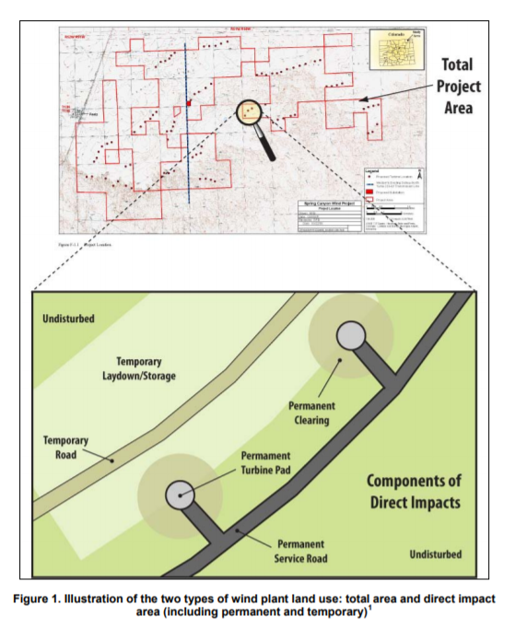

## Possible solutions (work that WE can do)

* 1. Plot a map with their results + affected area: they just plot the position of the wind plants, but we can include 2 polygons (total area) and (temporary area) and compare visualize with their results:

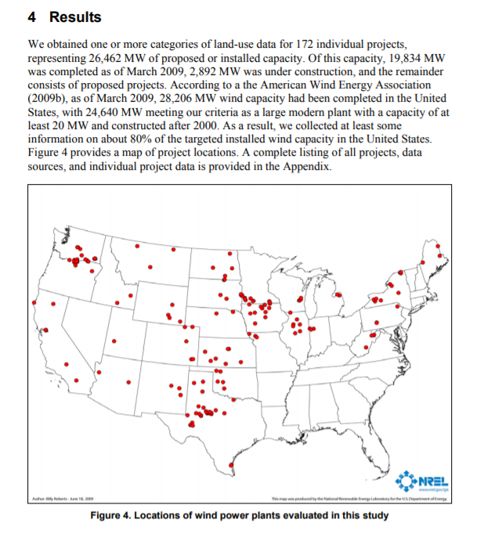 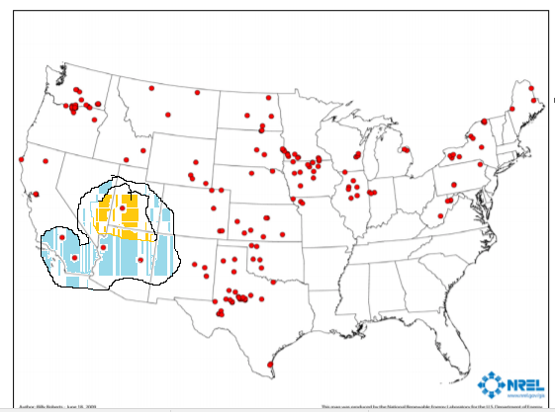

**Left**: original plot. **Right**: Simple example: yellow area = total area of project. Blue area = total area + temporary area

* 1. Compare these wind project whit the BEST possible locations with a 2nd layer showing wind conditions, available land (with less possible impact to population and nature biome)
  2. Extend the analysis with Actual wind park. The article was written in 2009…. A lot of new wind power plants arrives.
  3. Build a model, if someone input the necessity of energy the system puts in the map the possible area, number of winds generators, impacted area and cost of the project (using a rule of thumb of $EUR/km2)